(Approx. 315 words)

Do Not Track Plus by Abine.com
Reviewed by Larry Mobbs, President, Computer Operators of Marysville and Port Huron, MI
March 2012 issue, COMP Communicator
www.bwcomp.org
Lmobbs (at) comcast.net

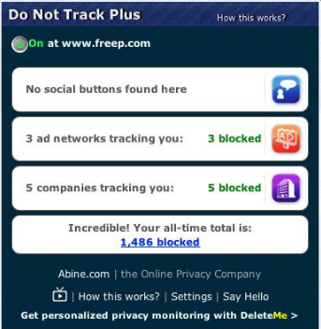
A new program offered free from Abine software allows you to block websites you visit from tracking where you browse. Many sites, and Facebook.com is one of the worst, want to track every site you visit so they can match up your preferences to the items they want to display on you wall for advertisers.

In the software industry there is a movement to have the browsers include a plugin that
prevents this action but as of yet it is not ordered and may never be. Browser publishers may take this on from their own volition but they will be pressured by advertisers not to.

One must remember that many sites depend on you or others visiting the links they place on their pages in order to pay for the website.

When you run Abine it puts a small icon in your browser and it displays a number with each site you visit, telling you how many attempts are made to track your visit and what type of tracking company is making the effort. They also keep a running grand total of how many blocks they have made. In the first few days of my use on one machine they
blocked 1600 attempts.

Installation following the quick download is painless and there is virtually no setup. While writing this article I loaded Firefox, downloaded the software and ran it as a plugin.

This is required for each browser you use. After restarting Firefox I visited cnn.com and
Donottrack Plus reported blocking 13 attempts to track my browsing on their site.

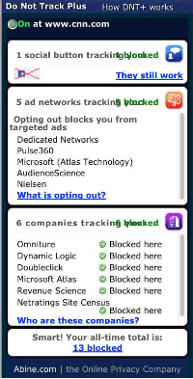
It looked like this (see right).

The program came highly recommended by Cnet.com, which is where I read about it. It can be downloaded from Abine.com.

